

**Customer_retention_case study**

Submitted by:

SNEHA SANTRA

**ACKNOWLEDGMENT**

DATA

The source of this dataset is fliprobo technology. The dataset consists of text and metadata which is scrapped

The dataset has 71 columns and 269 rows in the

dataset where each row corresponds to a new article. For the classification problem under

consideration we have used ‘title’ and ‘text’ as input columns and column ‘type’ as output

variable. The title, text and type are of string data type.

There is no missing values in this dataset.

**INTRODUCTION**

* Business Problem Framing

Customer satisfaction has emerged as one of the most important factors that guarantee the success of online store; it has been posited as a key stimulant of purchase, repurchase intentions and customer loyalty. A comprehensive review of the literature, theories and models have been carried out to propose the models for customer activation and customer retention.

* Conceptual Background of the Domain Problem

The project is sub-divided following section. These are:

1. Loading necessary libraries

2. Loading Dataset from a CSV file or from a Table.

3. Summarization of Data to understand Dataset (Descriptive Statistics)

4. Visualization of Data to understand Dataset (Plots, Graphs etc.)

* Motivation for the Problem Undertaken

Five major factors that contributed to the success of an e-commerce store have been identified as: service quality, system quality, information quality, trust and net benefit. The research furthermore investigated the factors that influence the online customers repeat purchase intention. The combination of both utilitarian value and hedonistic values are needed to affect the repeat purchase intention (loyalty) positively. The data is collected from the Indian online shoppers. Results indicate the e-retail success factors, which are very much critical for customer satisfaction.

**Analytical Problem Framing**

* Data Sources and their formats

The source of this dataset is fliprobo technology. The dataset consists of text and metadata which is scrapped

The dataset has 71 columns and 269 rows in the

dataset where each row corresponds to a new article. For the classification problem under

consideration we have used ‘title’ and ‘text’ as input columns and column ‘type’ as output

variable. The title, text and type are of string data type.

There is no missing values in this dataset.

**Dataset –Customer_retention_dataset**

Columns:There are 71 columns along with gender,how old are you,which city do u shopping, Since How Long You are Shopping Online ,etc

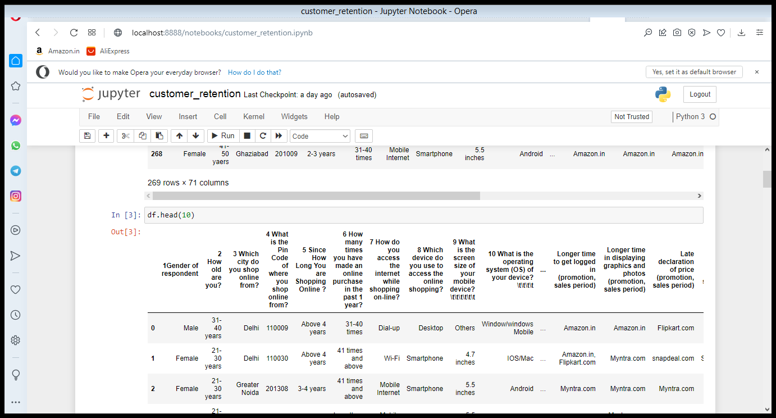

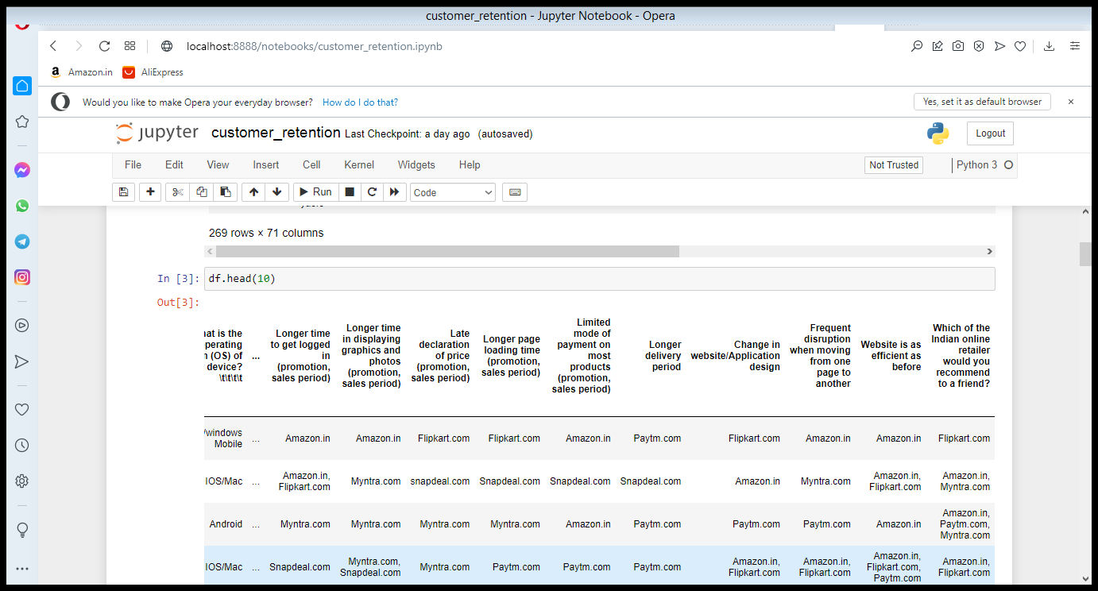

* + - * Data Preprocessing Done
        + Feature Engineering:we use a heat map for features the main columns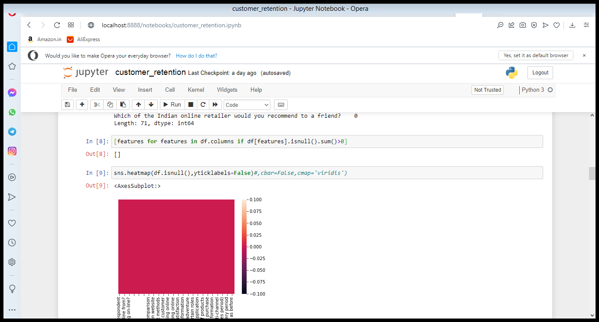
        + Data Distribution: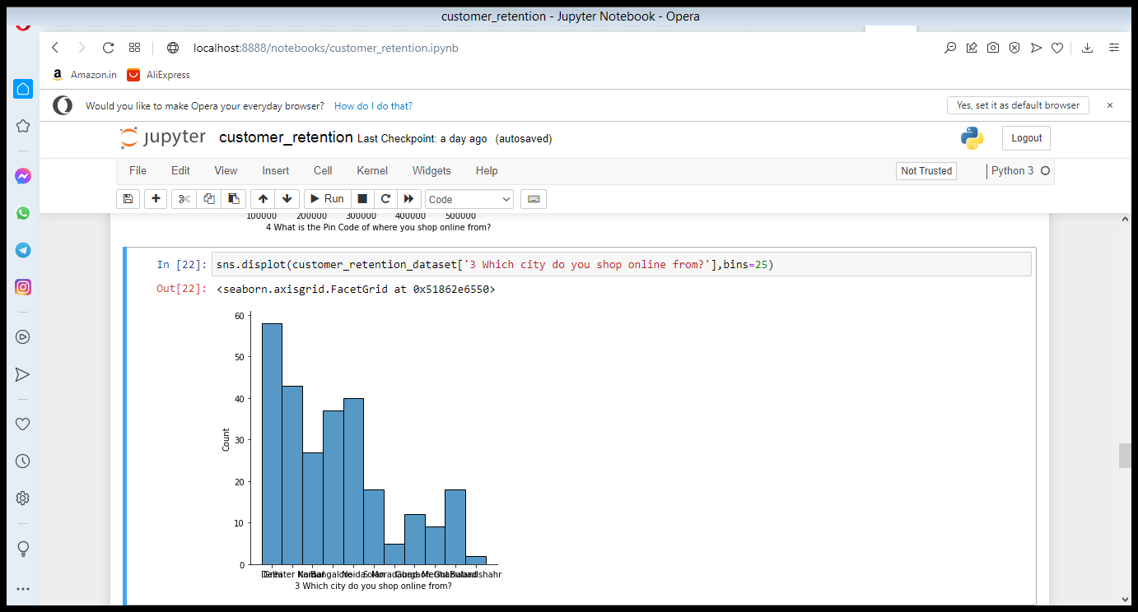

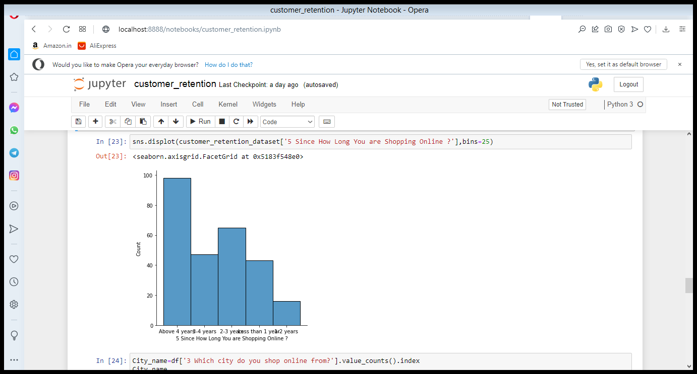

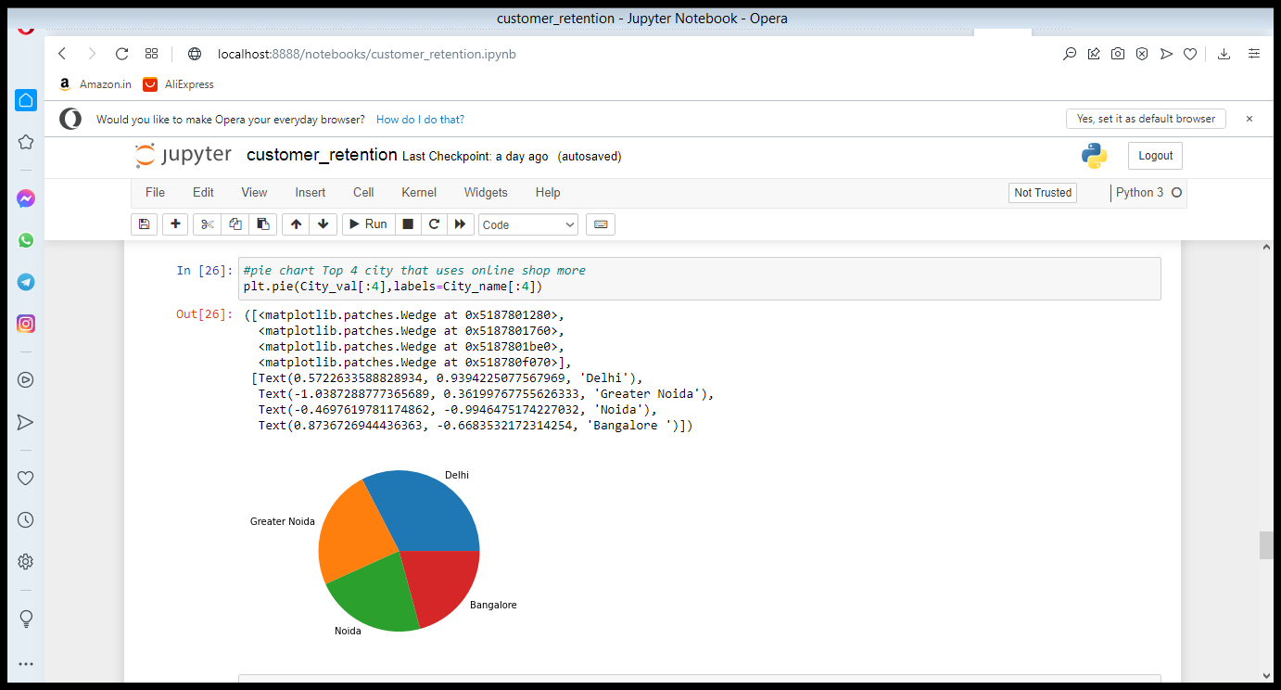

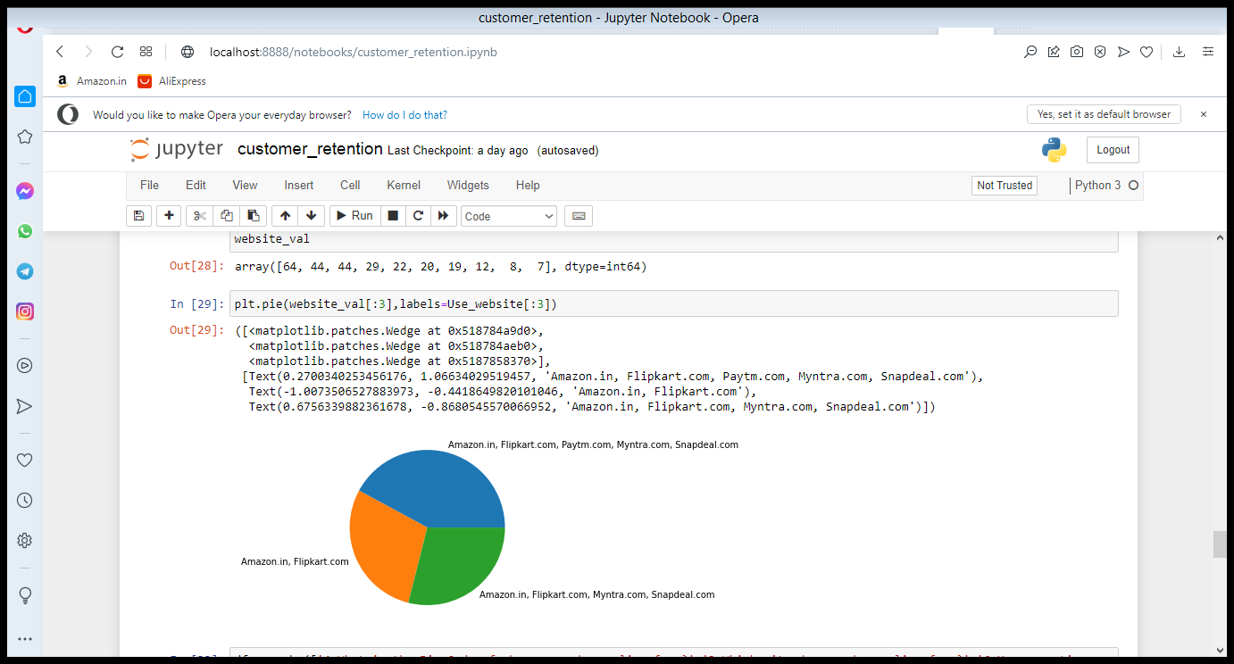

Handling missing value-There is no null value or missing value in this dataset

* Data Inputs- Logic- Output Relationships

Here we saw that the output is how much people using onling shopping and it is based on some input those are which city is more use online shopping and here we shaw that delhi is in number 1 for online shopp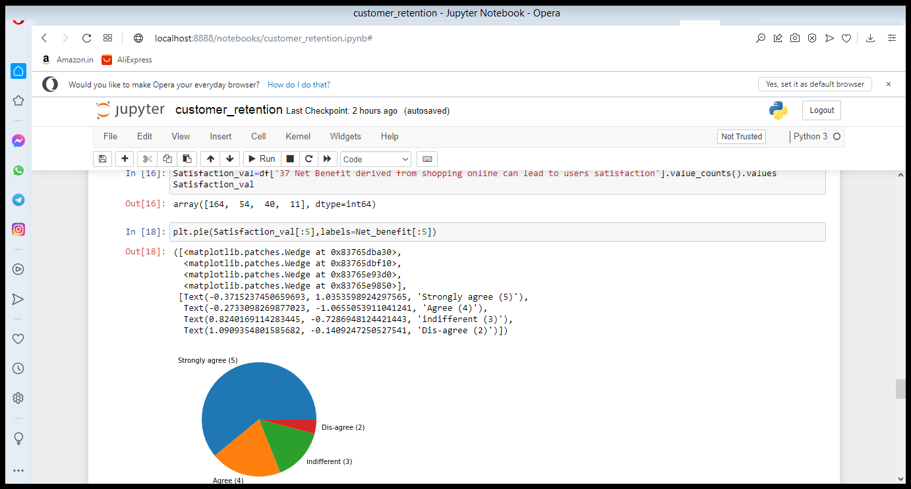ing

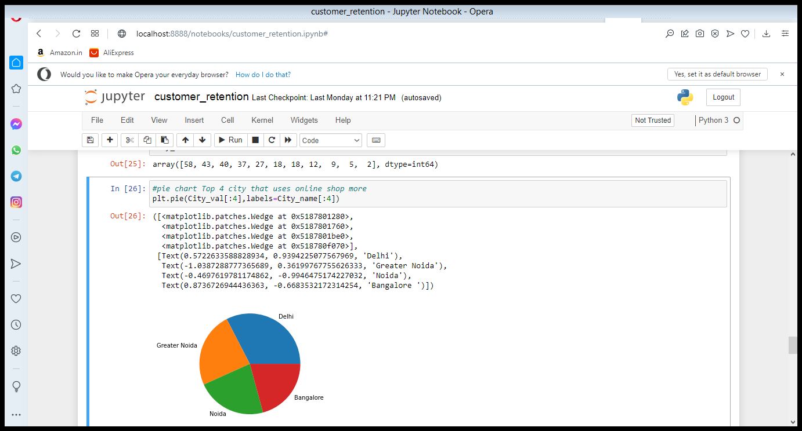

* Hardware and Software Requirements and Tools Used

References-Dataset-Customer_retention_dataset from fliprobo technology

**CONCLUSION**

* Key Findings and Conclusions of the Study

In terms of EDA process and data visualisation process I find out which city is mostly used online shopping and which online portal is frequently used for shopping more and how long since u r shopping online and we notice that trust and net benefit for online shopping is strongly agree by customer and they clearly mention that online shopping give more discount so this are the key for the success of online shopping.

* Limitations of this work and Scope for Future Work

Five major factors that contributed to the success of an e- commerce store have been identified as: service quality, system quality, information quality, trust and net benefit. The research furthermore investigated the factors that influence the online customers repeat purchase intention. The combination of both utilitarian value and hedonistic values are needed to affect the repeat purchase intention (loyalty) positively.